**Batch Time Analysis of Transactional Data**

**Objective:**

To use AWS Big Data stack for data engineering to analyze transactions, uncover patterns, and share actionable insights

**Solution:-**

**Steps:**

1) Create an S3 bucket with a unique name i.e. “gopi32”

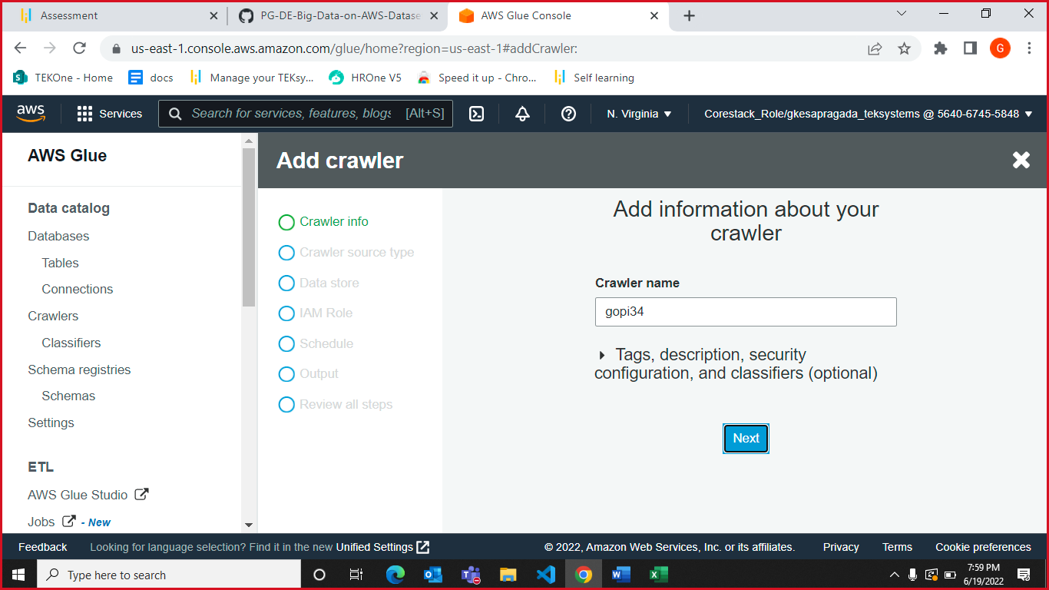

2) upload the CSV file to the S3 bucket (ensure that the file is in UTF-8 format only).

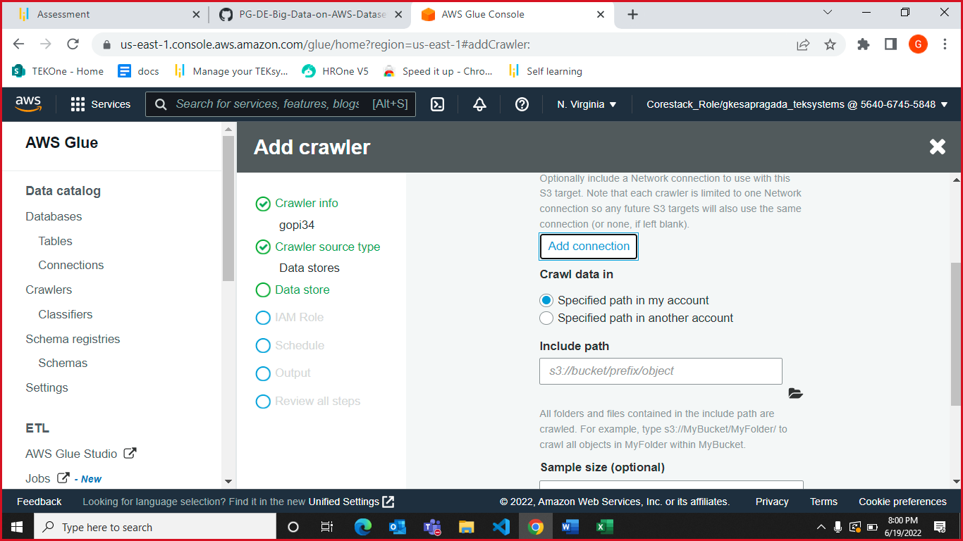

In order to ensure that the file is in UTF-8 format open the excel file go to save as and select UTF-8 .csv as option and save it on your desktop as shown below.

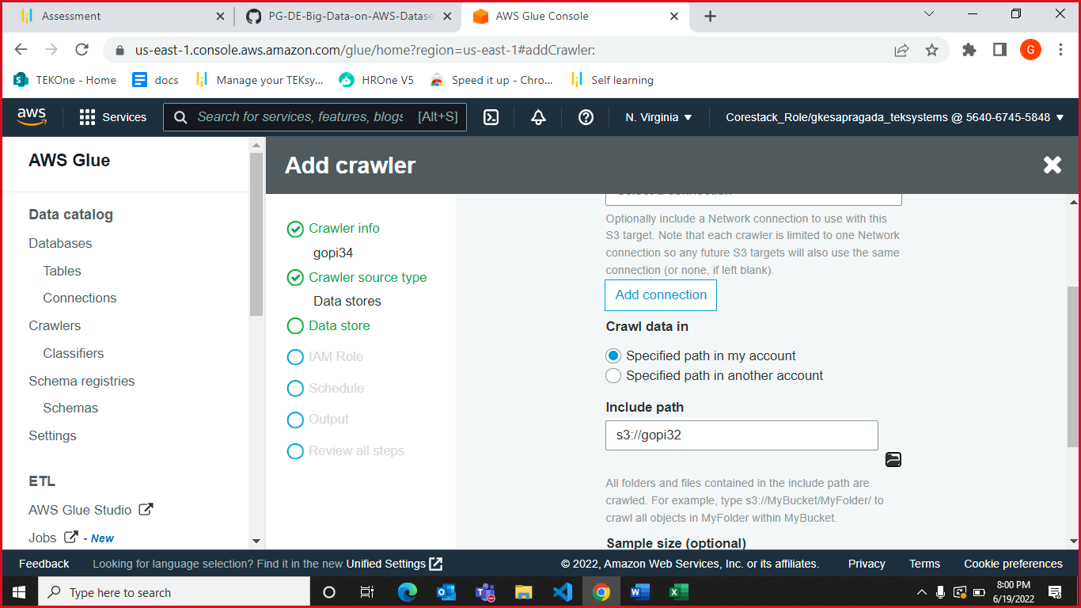

Create a crawler to crawl the CSV data and generate a metadata catalog.For this go to AWS Glue

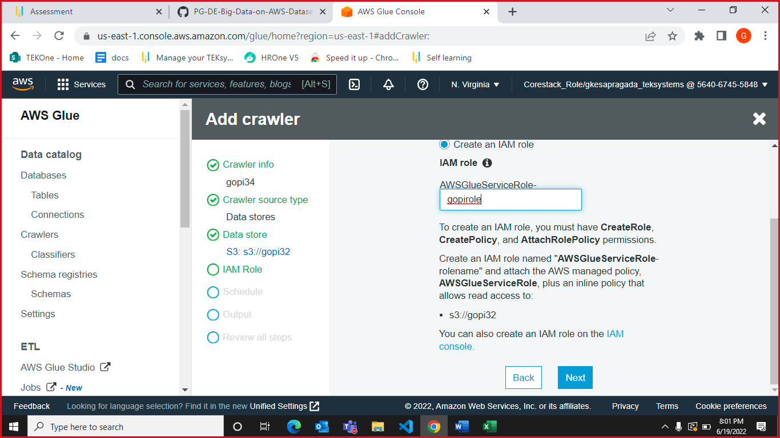

and select Crawler and then fill in the details as shown below

Now run the Crawler as it’s showing in starting phase.

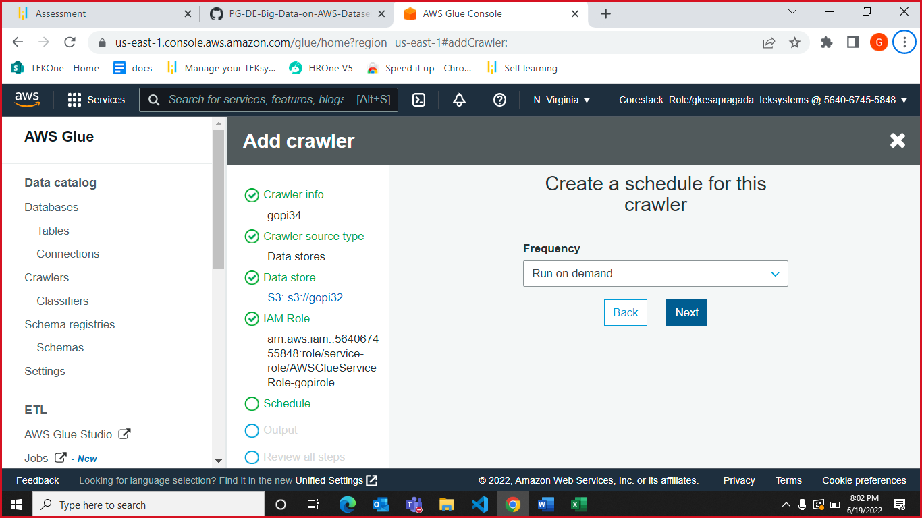

After successfully run, now you can see the “data_utf8_csv” file details in table catalog as shown below.

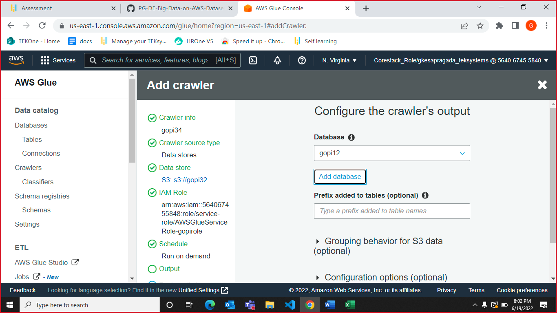

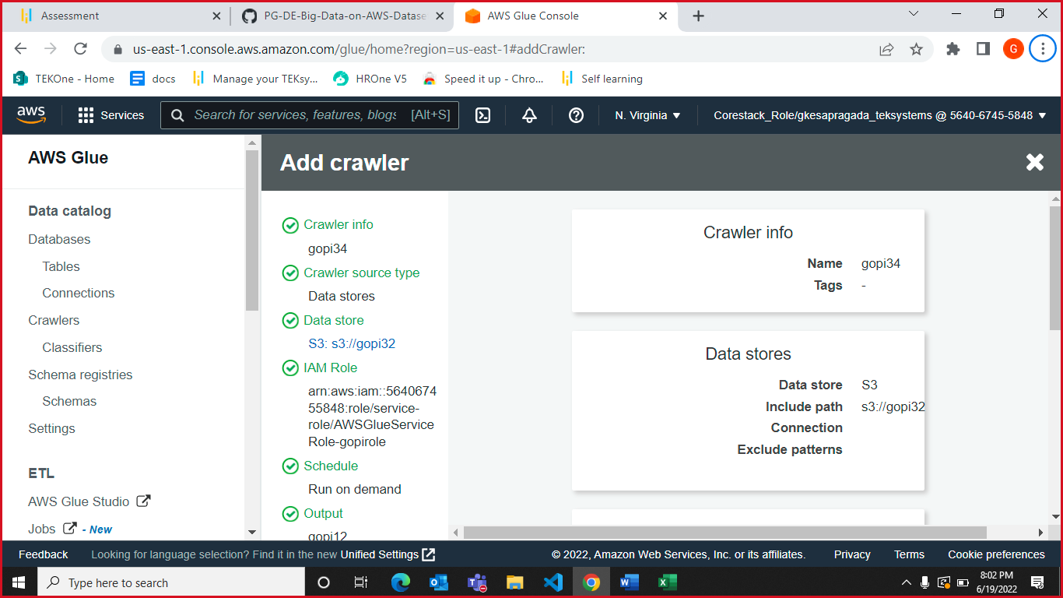

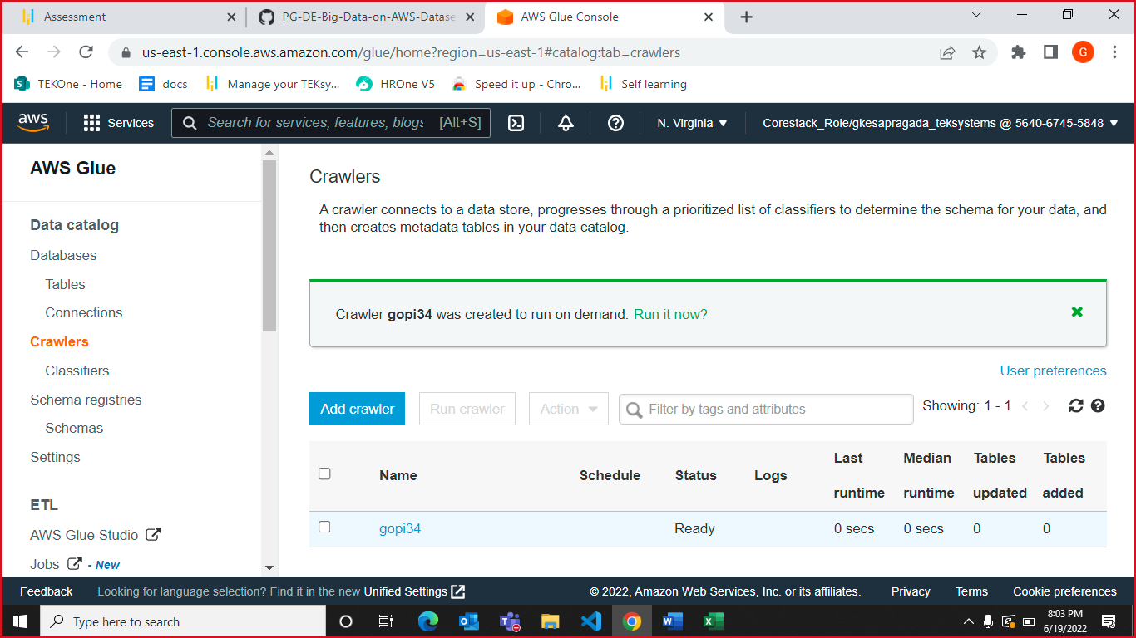

Now go to Aws Athena

You are able to see the data_utf8_csv table in Tables as shown below

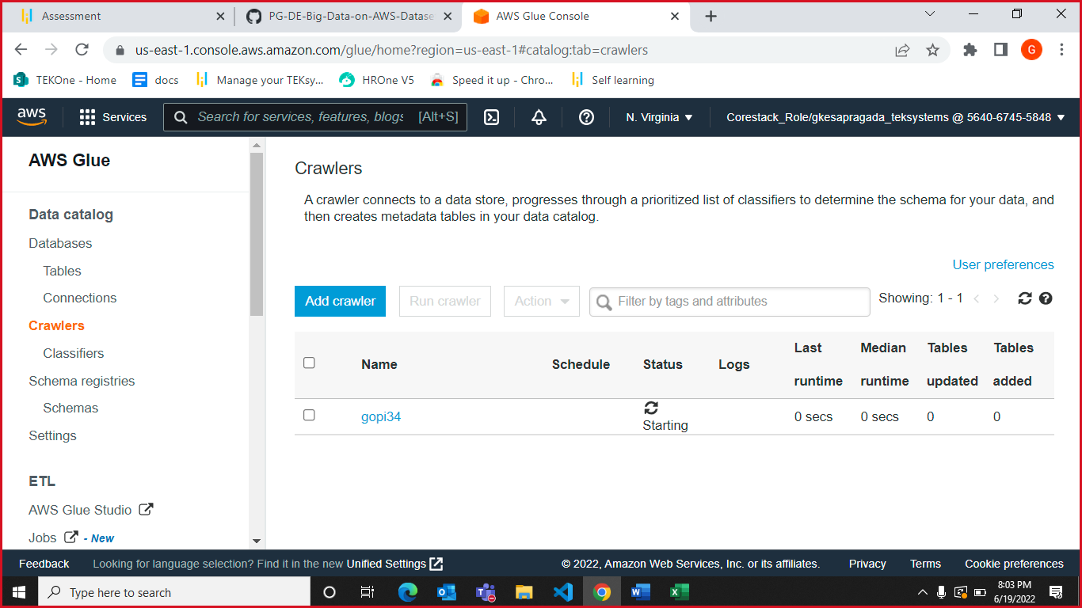

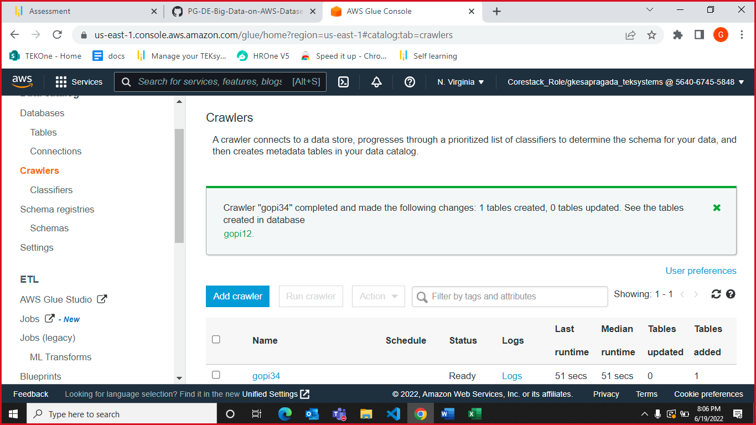

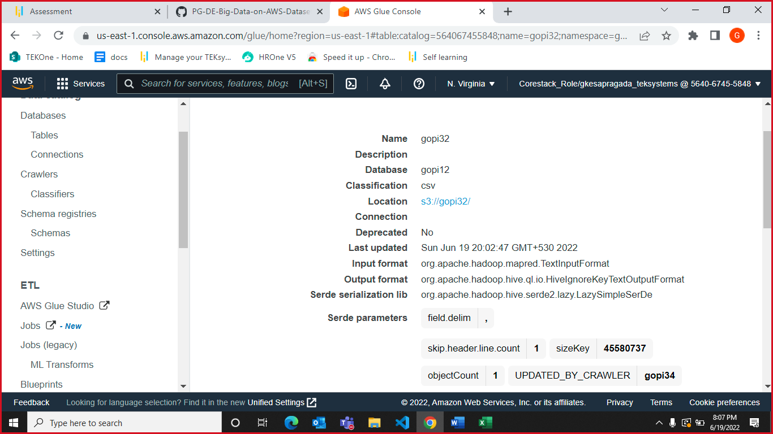

Now Query the data to identify the best-selling item and countries where customers have bought the most-sold item using Athena

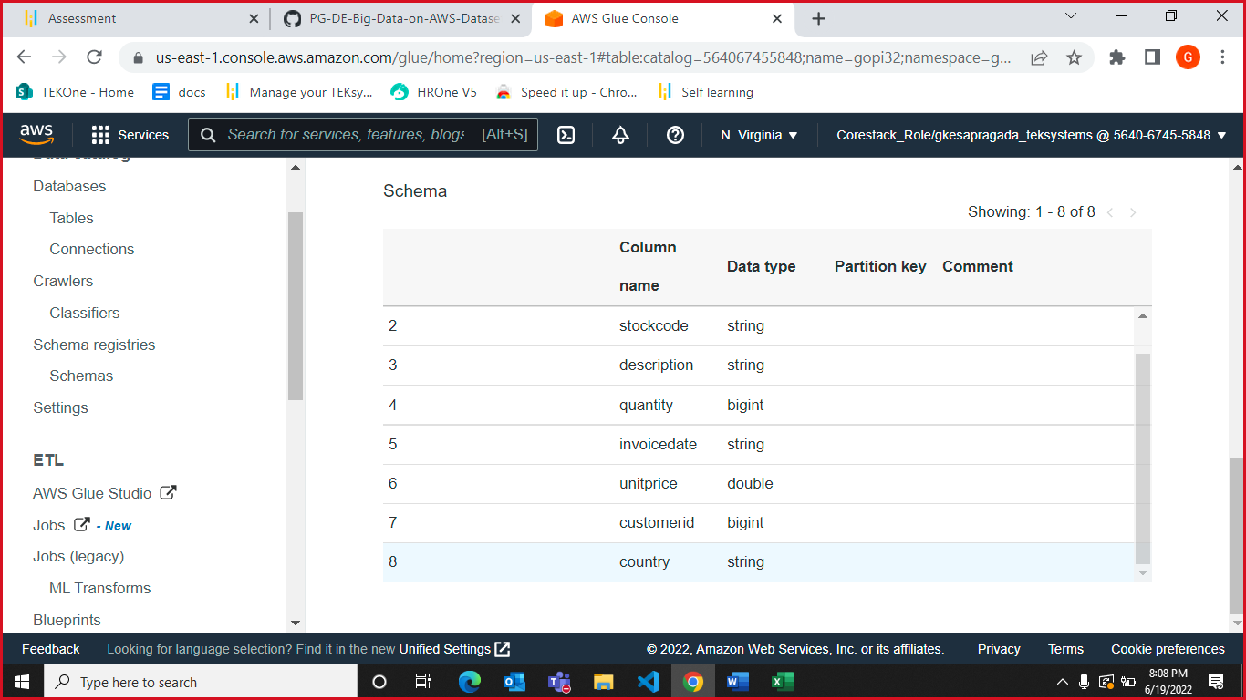

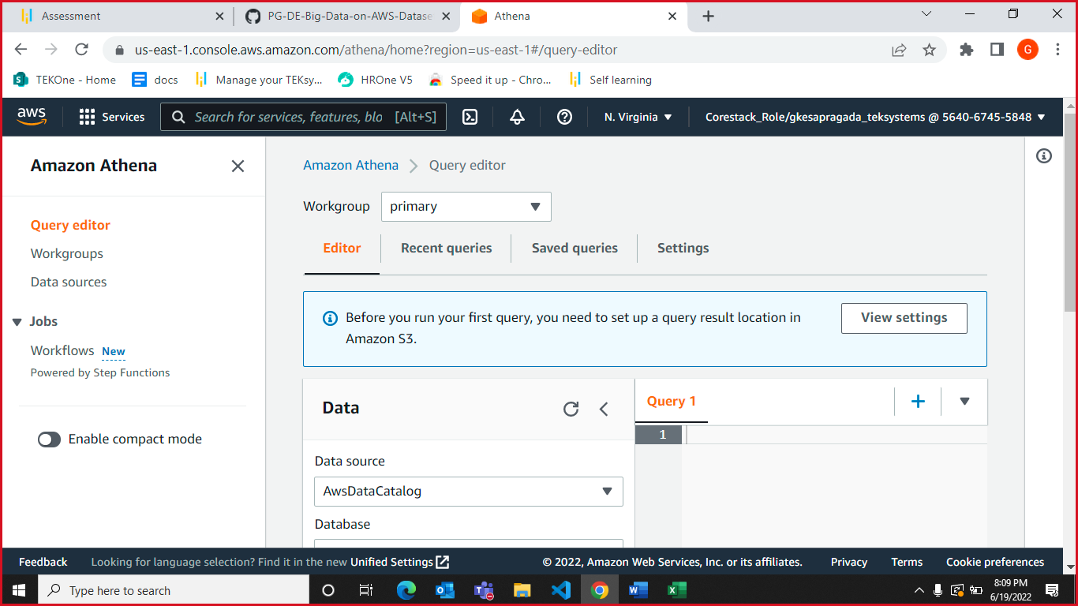

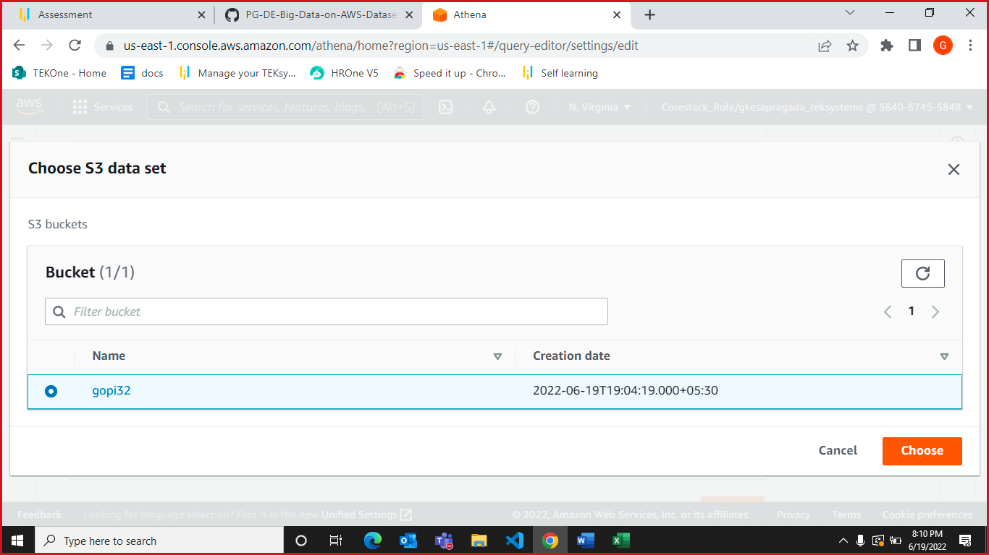

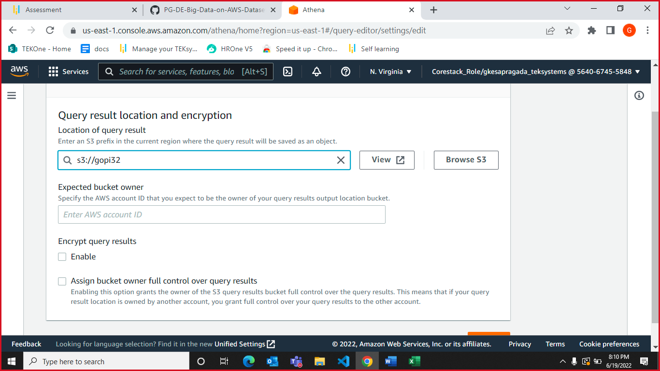

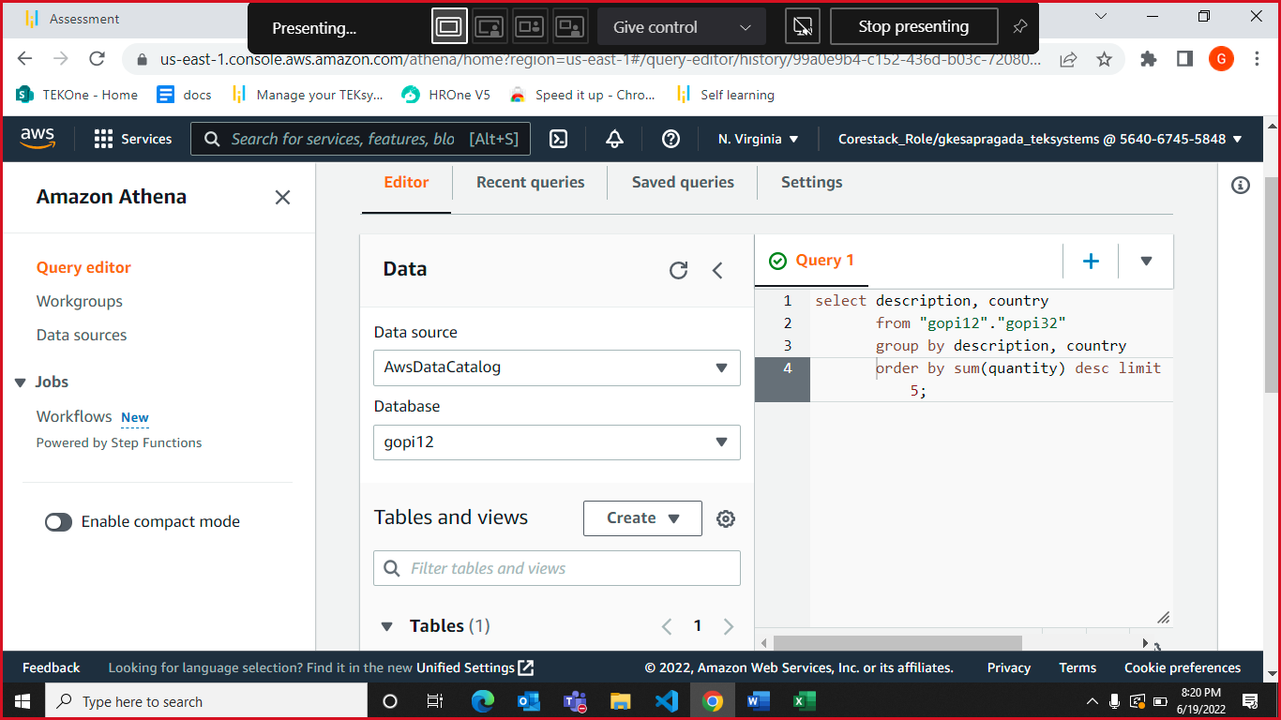

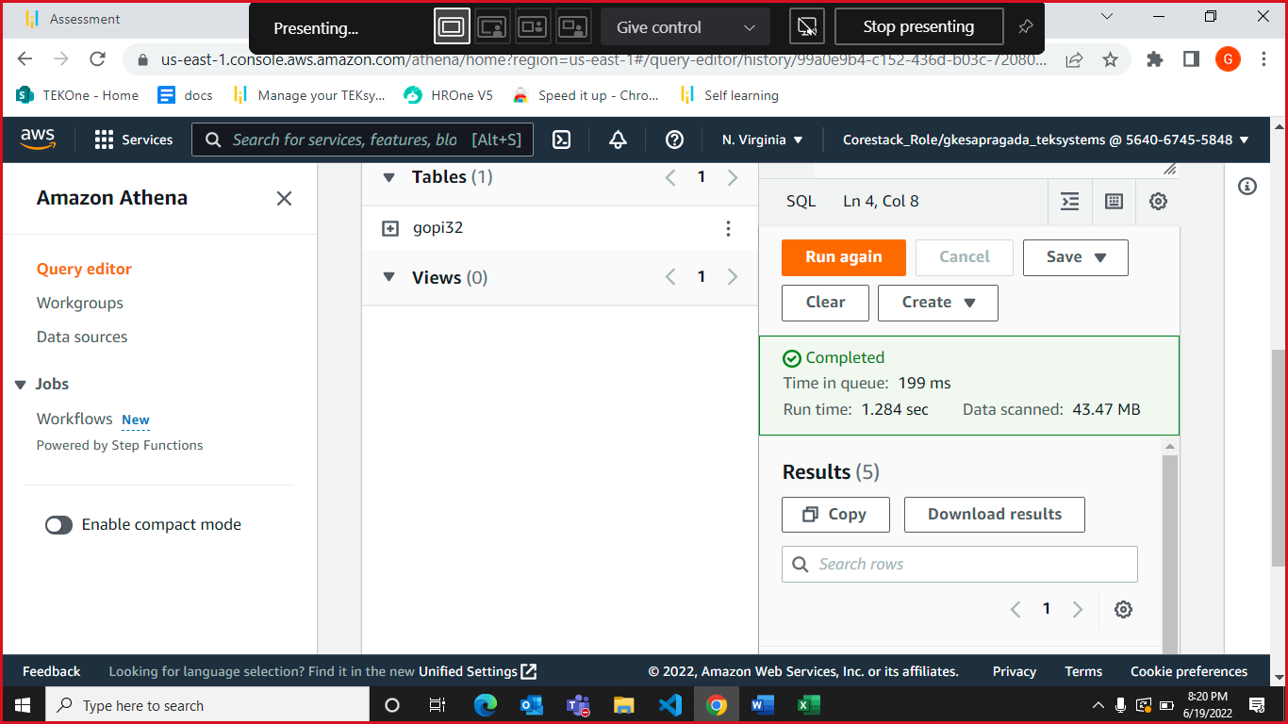

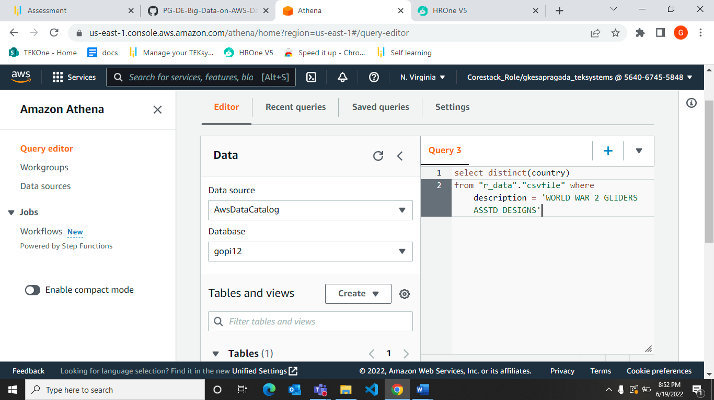

Batch Time Analysis of Transactional Data is completed and run successfully as shown above.